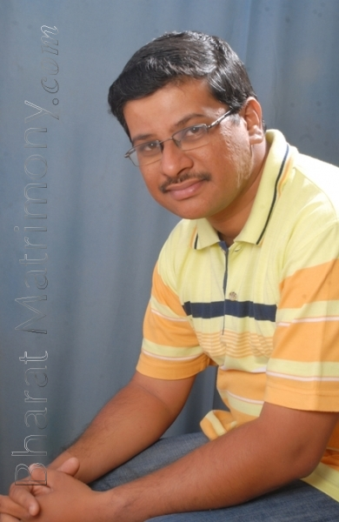

POTHAPRAGADA SIVAKUMAR
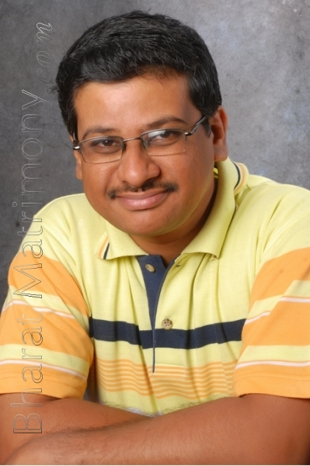
POTHAPRAGADA SIVAKUMAR

